**SMARTFARMER - IOT ENABLED SMART FARMING APPLICATION**

**NALAIYA THIRAN PROJECT BASED LEARNING**

## Submitted by

|  |  |
| --- | --- |
| **Team ID:PNT2022TMID15324** | |
| GOURU SUPRATHIKA | 111519104035 |
| GOLLA JAHNAVI | 111519104032 |
| ABBURI NOSHMA | 111519104002 |
| D.GURU PRAVALLIKA | 111519104026 |

in partial fulfilment for the award of the degree of

**BACHELOR OF ENGINEERING**

**IN**

**COMPUTER SCIENCE AND ENGINEERING**



**RMD ENGINEERING COLLEGE**

(AN AUTONOMOUS INSTITUTION)

R.S.M.NAGAR,KAVARAIPETTAI,

GUMMADIPOONDI TALUK,

THIRUVALLUR DIST

ANNA UNIVERSITY:: CHENNAI 601 206

NOV 2022

**INDEX**

# INTRODUCTION

* 1. Project Overview
  2. Purpose

# LITERATURE SURVEY

* 1. Existing problem
  2. References
  3. Problem Statement Definition

# IDEATION & PROPOSED SOLUTION

* 1. Empathy Map Canvas
  2. Ideation & Brainstorming
  3. Proposed Solution
  4. Problem Solution fit

# REQUIREMENT ANALYSIS

* 1. Non-Functional requirement
  2. Functional requirements

# PROJECT DESIGN

* 1. Data Flow Diagrams
  2. Solution & Technical Architecture
  3. User Stories

# PROJECT PLANNING & SCHEDULING

* 1. Sprint Planning & Estimation
  2. Sprint Delivery Schedule
  3. Reports from JIRA

# CODING & SOLUTIONING

* 1. Feature 1
  2. Feature 2
  3. Database Schema (if Applicable)

# TESTING

* 1. Test Cases
  2. User Acceptance Testing

# RESULTS

* 1. Performance Metrics

1. **ADVANTAGES & DISADVANTAGES**
2. **CONCLUSION**
3. **FUTURE SCOPE**

## Introduction:

* 1. **overview:**

In this project I have developed a mobile application using which a farmer can monitor the temperature, humidity, pressure and soil moisture parameters along with weather forecasting details. Based on these details he can water the crops by controlling the motors through the app .

## Purpose:

Agriculture plays a crucial role in the life of an economy. It is the backbone of our economic system, so improving the quality and way of production is crucial. Here comes the Smart Agriculture system. Smart agriculture helps in automated farming, collection of data from the field and then analyses it so that the farmer can make accurate decision in order to grow high quality crop.

IoT based Smart Farming improves the entire Agriculture system by monitoring the field in real-time. With the help of sensors and interconnectivity, the Internet of Things in Agriculture has not only saved the time of the farmers but has also reduced the extravagant use of resources such as Water. and Electricity.

## Literature Survey:

* 1. **Existing problem**

Agriculture is extremely dependent on the climate. Temperature increases and carbon dioxide can boost some crop yields depending on the location; but other conditions must also exist, such as humidity, pressure, and water availability. Although slight warming and more carbon dioxide in the atmosphere could benefit some plants to grow faster, severe warming, floods, and drought would reduce yields. Farmer need to spend a lot of time to maintain these.Heat is not

the only extreme weather. Extreme cold can benefit farmers by freezing the soil deep beneath the ground. In parts of the upper Midwest, frost depths exceed 40 inches. A deep frost depth can aid farmers in diverse ways. The cold helps nitrogen that is applied in the fall from vaporizing during the winter. The cycle of freezing and thawing of water helps soften the soil after the thaw. Extreme cold and frozen soils also reduce the survival rate of some insects.

Severe weather other than heat and cold can cause loss and devastation to a farm. Most farmers can’t avoid the results of extreme weather. Diverse extreme weather can affect farms in different ways. Because of this, it’s important that farmers have a proper system and need a mobile application to monitor the weather changes and to control the motor.

## Proposed solution

As the climates are changing rapidly and weather is unpredictable, so farmers are facing difficulties so they need a system to tackle this, here we use “open weather API” to get weather information such as temperature, pressure, humidity and weather description at their current location.

Based on which they can decide whether to turn on the motors or turn off the motor if needed temperature and moisture sensors from IBM simulator is displayed on UI for monitoring the weather. An algorithm developed with threshold values of temperature, pressure, humidity is programmed to intimate the farmer if weather conditions go bad. He can control motors remotely from any place through IoT. Internet interface that allow data inspection and irrigation scheduling to be programmed through mobile application or Node- RED UI. The technological development in software and hardware make it easy to develop this which can make better monitoring and wireless network made it possible to use in monitoring and control of greenhouse parameter in precision agriculture.

## Problem Statement Definition

Customer Problem Statement Template: Surya is a farmer, his brother completed Engineering course streamed in Electronic & Communication Engineering. His brother gave him the idea to improve agriculture with the help of the technology he learnt. It also helps him in reducing manpower. His brother is working on a new idea to improve the irrigation facility, soil fertility and crop rotation. This problem can be actively solved with the help of the application he is building.

|  |  |  |  |  |  |
| --- | --- | --- | --- | --- | --- |
| **Problem**  **Statement (PS)** | **I am**  **(Customer)** | **I’m trying to** | **But** | **Because** | **Which makes me feel** |
| PS-1 | Farmer | to water the crop or postpone it by monitoring the sensor parameters and controlling the motor pumps from the mobile application itself. | **it requires an unlimited or continuous internet connection to be successful**. | All the information is sent to mobile and to see the data of all the sensors we need continuous network | Frustated because sometimes sensors send wrong information ans providing continuous internet is difficult |

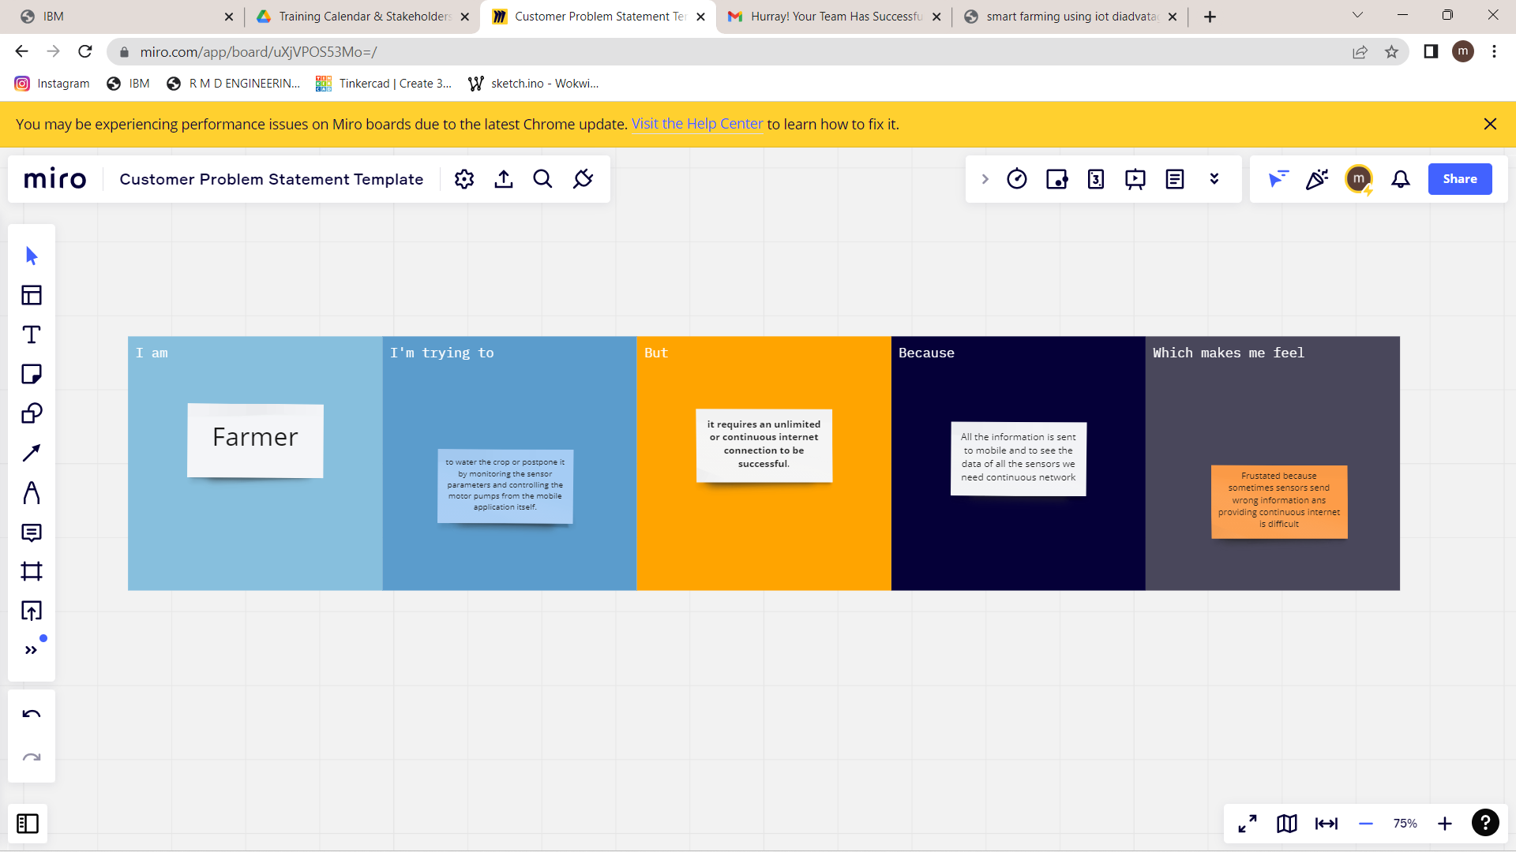

# IDEATION & PROPOSED SOLUTION:

## 3.3 Proposed Solution:

Project team shall fill the following information in proposed solution template.

|  |  |  |
| --- | --- | --- |
| **S.No.** | **Parameter** | **Description** |
| 1. | Problem Statement (Problem to be solved) | Farmers must wait on the field until the entire farm field is covered with water before they can water it. Power supply issues are another issue. The electricity supply in Village Side may be different. Information gaps, widespread adoption, high costs, security concerns, etc. are the biggest obstacles for IoT in the agricultural sector. |
| 2. | Idea / Solution description | 1. Similar to precision agriculture, smart farming techniques let farmers keep better track of their crops and maintain the appropriate humidity levels. 2. Information gathered by sensors Dew detections, temperature, moisture, and humidity measurements all aid in predicting the weather in farms. So, cultivation for suitable crops is carried out. |
| 3. | Novelty / Uniqueness | **ALERT MESSAGE:** IoT sensor nodes gather data from the agricultural environment, including soil moisture, air humidity, temperature, the nutrients in the soil, pest images, and water quality, and then send the gathered information to IoT backhaul devices.  **REMOTE ACCESS:** It helps the farmer to operate the motor from anywhere. |

|  |  |  |
| --- | --- | --- |
| 4. | Social Impact / Customer Satisfaction | 1. It saves a lot of time and lowers the wages paid to farm labourers. 2. By boosting the consumer experience overall, IoT can help strengthen customer relationships. 3. dentify maintenance requirements quickly, create better goods, deliver tailored communications, and more. |
| 5. | Business Model (Revenue Model) | IoT can also support the growth and sales of e-commerce companies.  800 740  **Users**  600 523  400 Users 350  200  200  2 per.  Mov. Avg.  0 (Users)  0 1 2 3 4 5 |
| 6. | Scalability of the Solution | Scalability in smart farming refers to a system's ability to expand its capacity, such as the number of technological components like sensors and actuators, while allowing for prompt analysis. |



✴

**Customer**

**experience journey map**

Use this framework to better understand customer needs, motivations, and obstacles by illustrating a key scenario or process from start to finish.

When possible, use this map to document and summarize interviews and observations with real people rather than relying on your hunches or assumptions.

Created in partnership with

**[Share template feedback](https://muralco.typeform.com/to/CiqaHVat?typeform-source=app.mural.co)**

**Need some inspiration?**

See a finished version of this template to kickstart your work.

**[Open example](https://app.mural.co/template/f59f644b-b4b4-47b5-9ed6-3a8c71ceb612/896b31fe-5597-40ef-9b06-3811a1a45ace)**

**Document an existing experience**

**TIP**

As you add steps to the experience, move each these “Five Es” the left or right depending on the scenario you are documenting.

Narrow your focus to a specific scenario or process within an existing product or service. In the **Steps** row, document the step-by-step process someone typically experiences, then add detail to each of the other rows.

**Entice**

**SCENARIO**

**Browsing, booking, attending, and rating a local city tour**

How does someone initially become aware of this process?

**Enter**

What do people experience as they begin the process?

**Engage**

In the core moments in the process, what happens?

**Exit**

What do people typically experience

as the process finishes?

**Extend**

What happens after the experience is over?

**Steps**

What does the person (or group) typically experience?

Smart farming leads to sustainable farming

**Farm automation, commonly referred to as "Farming 4.0," or "smart farming," is the use of data and information technologies to enhance the food quality and production methods of sophisticated farming systems.**

**Utilizing a variety of technologies, smart farming enables farmers to remotely monitor field conditions and manage their fields and activities from a single location.**

Agriculture may become more profitable for farmers with smart farming. Farmers will save money and effort by using fewer resources, and risks will be decreased by using more reliable spatially explicit data. Crops will be grown in the best possible conditions thanks to accurate, site- specific weather forecasts, yield projections, and probability maps for illnesses and disasters based on a vast network of weather and climate data.

The controlled-environment agriculture (CEA) technology can be used to optimise this modern concept of smart farming, whether it is carried out in greenhouses or through indoor methods. With CEA, all environmental factors, such as temperature, humidity, carbon dioxide, pH, etc., can be controlled and automated based on the Industry 4.0 trends.

Most importantly, smart farming systems don't need any prior professional knowledge to start your own cultivation; all you need is a rooftop or a backyard, the proper abilities, and a hands-on approach.

Large volumes of data are produced by smart sensors and gadgets, giving decision-makers additional flexibility.

Farmers may be able to work on their acres of land while still monitoring their assets across entities, such as their feld, machinery, and equipment, without having to be present thanks to the real-time data offered. Big data and IoT give farmers even more information they can use to increase productivity, improve efficiency, and safeguard food quality along the supply chain, from field to fork.

Evolutionary phase must play a main role in agricultural innovation. Decisions are made by real-time data to provide automation

Modern innovations like artificial intelligence (AI), the Internet of Things (IoT), and mobile internet can offer practical answers to the problems the world is currently facing. Therefore, the focus of this study is on innovative ways to smart farming (SF) from 2019 to 2021, and it provides examples of data collection, transmission, storage, analysis, and appropriate solutions.

**Interactions**

What interactions do they have at each step along the way?

**People:** Who do they see or talk to?

**Places:** Where are they?

**Things:** What digital touchpoints or physical objects would they use?

Internet must be facilitated for smart farming

Farmers must possess sufficient knowledge to understand the process / working if incase any error occurs.

Large scale farming looks pretty much difficult to deploy

IoT connects sensor devices to carry out a variety of fundamental functions, making it one of the fundamental cornerstones of smart systems. These sensors were part of the smart irrigation system, which also included sensors for weather, irrigation efficiency, and water level. Smart controls, sensors, and a few mathematical relationships are the foundation of smart irrigation.

Additionally, this work highlights the significance of utilising a 5G mobile network in the development of smart systems because it allows for high-speed data transfer of up to 20 Gbps and can connect a significant number of devices per square kilometre.

The development of IoT systems that improve animal welfare has previously been done to modernise agriculture. These systems employ data gathered from a range of sensors to guarantee that all operations are being carried out within a certain parameter and warn farmers of any difficulties.

Agriculture and farming, as

we can see, are vastly different than they were in the past, thanks to the use of

contemporary technologies.

Utilizing cutting-edge technology is a key component of smart agriculture and will be necessary on farms in the future. The Internet of Things (IoT), a network of machines that are now talking with one another for the first time, is at the core of smart agriculture.

These machines help farmers better understand what's occurring on their property and make important decisions on a number of crucial levels by gathering and sharing data through a network.

Modern equipment, tools, and sensors are frequently used by farmers in their activities.

They employ the most cutting-edge farming technologies currently obtainable.

Even though the entire farming system must be changed, traditional agricultural practises must be supplemented with sensing and driving technologies.

**Goals & motivations**

At each step, what is a person’s primary goal or motivation? (“Help me...” or “Help me avoid...”)

Main vision of this project is to segregate real values and provide analysis as well as automation process

Mission of the project ensures technology driven to generate message on applications to notify the end user

**Positive moments**

Farmers will save money and effort by using fewer resources, and risk will be reduced by using more reliable spatially explicit data.

As it requires less human effort, time is unquestionably saved. The main thing that an IoT platform can save you is time.

Smart farming can offer a concerted escape from fixed technology and practises that are polarising and market-segmented.

Farmers can set up and automate warnings using equipment each time inconsistencies are found and reported by sensors.

Agriculture may become more profitable for farmers with smart farming.

Additionally, smart farming may increase customer acceptance.

In the world of agriculture, specific equipment that enables production stockroom monitoring with the aid of sensors is essential.

IoT predominantly works in automation progress in agricultural field

It is necessary to reduce greenhouse gas emissions if we want to combat climate variability and extremes.

The idea is swiftly gaining traction and upending the agricultural industry to enable the farm of the future. High- precision crop control, meaningful data gathering, and automated farming methods are all part of smart farming. It is a technology that enables disease prediction and prevention, near-real- time monitoring of soil and crop condition data, and automatic feeding and watering of crops. The storage needed to store the data we will be gathering is readily available thanks to the cloud.

It strives to address two key goals: I sustainably raising agricultural revenues and output.

Building resilience to climate change through adaptation.

For agriculture to become sustainable, smart farming is essential.

Farming trucks and equipment fitted with IOT sensors will allow position tracking and preventative maintenance by spotting faults.

As a result,it improves the quality of farm and also the yield

Approaching better agricultural model

What steps does a typical person find enjoyable, productive, fun, motivating, delightful, or exciting?

The internet of Farm is a group that supports precise farming. It investigates the role of IoT in agriculture and how future farming in Europe will impact it. We focus on employing technology to develop crops, milk, meat, and other parts of agriculture. They host conferences and donate money for research. Over 120 companies are present at the corporation.

One of their objectives is to lessen greenhouse water usage and use technology to manage the food supply chain. By implementing this contemporary technology across all types of farms and enterprises, it transforms agriculture.

**Negative moments**

Since IoT systems are networked and connected, they can interact. Despite security precautions, the system is not very controllable and is vulnerable to different network attacks.

With regard to climate change, land degradation, governmental mandates, restrictions, and other factors, farms have to adapt.

The fact that smart farming necessitates an unrestricted or ongoing internet connection for success is a major drawback.

increased in maintenance

Challenges must be resolved in new areas where implementing IoT

It's possible that smart farming will call for specific skill sets in order to comprehend and use the machinery.

What steps does a typical person find frustrating, confusing, angering, costly, or time-consuming?

With a projected CAGR of 9.7% from 2021 to 2027, the worldwide smart agriculture market is expected to grow from its current value of $16,746.7 million in 2019 to

$29,234.6 million by 2027.

Every object is connected to each other in the Internet of Things (IoT) concept by a special identifier so that it can transmit data to human interaction across the network.

Farmers must therefore receive enough training so they can monitor the dynamics of pests and illnesses and make the best decision at the appropriate time.

The year 4.0 is here. also for agriculture: by creating innovative Smart Agriculture solutions, it is possible to benefit from a developing market that presents chances for businesses that support an ecologically responsible use of resources.

The time required for prioritising the use of resources and for administrative tasks would decrease if all farming-related data were collected by automated sensors.

Future food demand brought on by rising incomes and people will necessitate a significant increase in agricultural output. Globally, due to the consequences of climate change, arable land is disappearing and water shortage is becoming a greater problem. In this context, the Internet of Things (IoT) and other technologies are crucial in assuring sustainable production, which secures the future of the agricultural industry.

Social factors Involving end users in development

rise in proftability better working environment

When differences are spotted and corrected by sensors, equipment enables farmers to set up and automate notifications.

the potential for error Analysis of Weather Conditions - In the case of agriculture, the majority of the cycle is weather-specific. Given the altered technologies, it is a natural phenomenon that might become unpredictable. There is a problem with intelligent agriculture where computers might have a negative impact on the environment.

The fact that technology calls for multiple computers means that data errors frequently occur.

The employment of machinery in smart farming has the potential to have a negative effect on the environment.

**Areas of [opportunity](https://app.mural.co/template/f59f644b-b4b4-47b5-9ed6-3a8c71ceb612/896b31fe-5597-40ef-9b06-3811a1a45ace)**

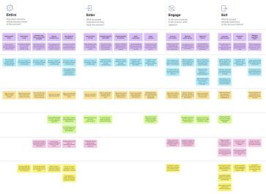

**Template**

How might [we make each step](https://app.mural.co/template/f59f644b-b4b4-47b5-9ed6-3a8c71ceb612/896b31fe-5597-40ef-9b06-3811a1a45ace) better? What [ideas do we have?](https://app.mural.co/template/f59f644b-b4b4-47b5-9ed6-3a8c71ceb612/896b31fe-5597-40ef-9b06-3811a1a45ace) What have [others suggested?](https://app.mural.co/template/f59f644b-b4b4-47b5-9ed6-3a8c71ceb612/896b31fe-5597-40ef-9b06-3811a1a45ace)

Updating in the progress should be reported to the end user(farmer)

Various technologies involving in the core infrastructure of smart farming like big data , cloud computing, artificial intelligence and robotics

**1**

**Template**

**Define your problem statement**

What problem are you trying to solve? Frame your problem as a How Might We statement. This will be the focus of your brainstorm.

**5 minutes**

**2**

**Brainstorm**

Write down any ideas that come to mind that address your problem statement.

**10 minutes**

**4**

**Prioritize**

**3**

**Group ideas**

Take turns sharing your ideas while clustering similar or related notes as you go. Once all sticky notes have been grouped, give each cluster a sentence-like label. If a cluster is bigger than six sticky notes, try and see if you and break it up into smaller sub-groups.

**20 minutes**

Your team should all be on the same page about what's important moving forward. Place your ideas on this grid to determine which ideas are important and which are feasible.

**20 minutes**

**Jananee E**

IoT-based smart farming helps growers and farmers to decrease waste and improve production across a range of metrics, including the amount of fertiliser used, the number of trips the farm vehicles have made, and the effective use of resources like water, energy, etc.

It consists of a temperature sensor, a moisture sensor, a water level sensor, and DC power supply.GPRS module and moto When IOT is used Agriculture surveillanceWhen the system boots up, it checks thewater level, humidity, and temperaturemoisture content

**Problem**

Farmers are under pressure to increase food production while consuming less water and energy. Using a remote monitoring and control system, farmers may successfully handle these pressures.

|  |  |  |  |  |  |  |  |
| --- | --- | --- | --- | --- | --- | --- | --- |
|  | | | | | | | |
| It consists of a temperature sensor, a moisture sensor, a water level sensor, and DC power supply.GPRS module and moto When IOT is used Agriculture surveillanceWhen the system boots up, it checks thewater level, humidity, and temperaturemoisture content |  |  |  |  | |  |  |
|  |  |  |  |  | | IoT-based smart farming helps growers and farmers to decrease waste and improve production across a range of metrics, including the amount of fertiliser used, the number of trips the farm vehicles have made, and the effective use of resources like water, energy, etc. |
|  |  | It made farming easier to temperature sensor, moisture sensor, water level sensor, DC motor, and GPRS module. The IOT- based farm monitoring system begins by analysing the moisture, humidity, and water levels. |  |  | |  |
|  |  |  |  |  | Lack of information, high adoption costs, security concerns, and other issues are the major obstacles for IoT in the agricultural sector. The majority of farmers are unaware of the use of IoT in agriculture. | |
|  |  |  |  |  |
|  | |  |
|  |  |  |  |  | |  |

**Brainstorm**

**& idea prioritization**

For Smart Farming - IoT enabled Smart Farming Application

The majority of farmers in India employ conventional farming implements like the sickle and plough. Energy and labour are wasted as a result, and the output per worker is decreased. The machine is hardly ever used for transporting, harvesting, or irrigation.

One of the challengingtasks in farming is watering the plants, which requires them to wait for the entire field to be flooded. He had to spend 30 minutes inspecting the field.

It consists of a temperature sensor, a moisture sensor, a water level sensor, and DC power supply.GPRS module and moto When IOT is used Agriculture surveillanceWhen the system boots up, it checks thewater level, humidity, and temperaturemoisture content

The information gathered by sensors about humidity, temperature, moisture precipitation, and dew detection aids in forecasting the weather on farms so that appropriate crops can be cultivated.

**Dhivya S**

The crops are observed by sensors positioned along the farms for variations in light, humidity, temperature, shape, and size. The sensors examine any irregularity they find, then alert the farmer. Therefore, remote sensing can monitor crop growth and help stop the spread of disease.

**10 minutes** to prepare

**1 hour** to collaborate

**2-4 people** recommended

In order to regulate the amount of water required for irrigation and choose the most advantageous kind of cultivation, soil health analysis helps to identify the nutrient value and drier parts of farms, soil drainage capacity, or acidity.

Overuse of fertiliser and insecticides in agricultural fields damages crops and decreases field productivity, making the soil more susceptible to pest infestations. IoT apps can inform the farmer or user of the type and quantity of pesticides needed for the crop.

IoT-based smart farming helps growers and farmers to decrease waste and improve production across a range of metrics, including the amount of fertiliser used, the number of trips the farm vehicles have made, and the effective use of resources like water, energy, etc.

Deal with soil erosion, climate change, and biodiversity loss. satisfy consumers' evolving expectations and desires.

Increasing demand for higher-quality food must be met. Invest in increasing farm productivity.

**Manish Sakkaravarty A**

Lack of information, high adoption costs, security concerns, and other issues are the major obstacles for IoT in the agricultural sector. The majority of farmers are unaware of the use of IoT in agriculture.

The way data is gathered from various nodes in a farm is changing thanks to remote sensing. IoT-based remote sensing uses sensors installed next to farms, like weather stations, to collect data, which is then sent to analytical tools for study.

**Person 4**

The enhanced agility of the operations is one advantage of implementing IoT in agriculture. Farmers can swiftly respond to any significant change in weather, humidity, air quality, as well as the condition of each crop or soil in the field, thanks to real-time monitoring and forecast systems.

The idea behind smart farming is to give the agricultural sector the infrastructure it needs to exploit cutting-edge technologies, such as big data, the cloud, and the internet of things (IoT), for automating, tracking, and analysing activities.

**[Share template feedback](https://muralco.typeform.com/to/CiqaHVat?typeform-source=app.mural.co)**

**Importance**

If each of these tasks could get done without any difficulty or cost, which would have the most positive impact?

It made farming easier to temperature sensor, moisture sensor, water level sensor, DC motor, and GPRS module. The IOT-based farm monitoring system begins by analysing the moisture, humidity, and water levels.

Robots, drones, remote sensors, computer imagery, and ever-evolving machine learning and analytical tools are used in IoT in agriculture to monitor crops, survey and map fields, and give farmers information they may use to make time- and money-saving farm management decisions.

It made farming easie to temperature sensor, moisture sensor, water level sensor, DC motor, and GPRS module. The IOT-based farm monitoring system begins by analysing the moisture, humidity, and water levels.

One of the challenging tasks in farming is watering the plants, which requires them to wait for the entire field to be flooded.

He had to spend 30 minutes inspecting the field.

**Feasibility**

Regardless of their importance, which tasks are more feasible than others? (Cost, time, effort, complexity, etc.)

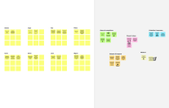

**Need some inspiration?**

See a finished version of this template to kickstart your work.

**[Open example](https://app.mural.co/template/e5a93b7b-49f2-48c9-afd7-a635d860eba6/93f1b98d-b2d2-4695-8e85-7e9c0d2fd9b9)**

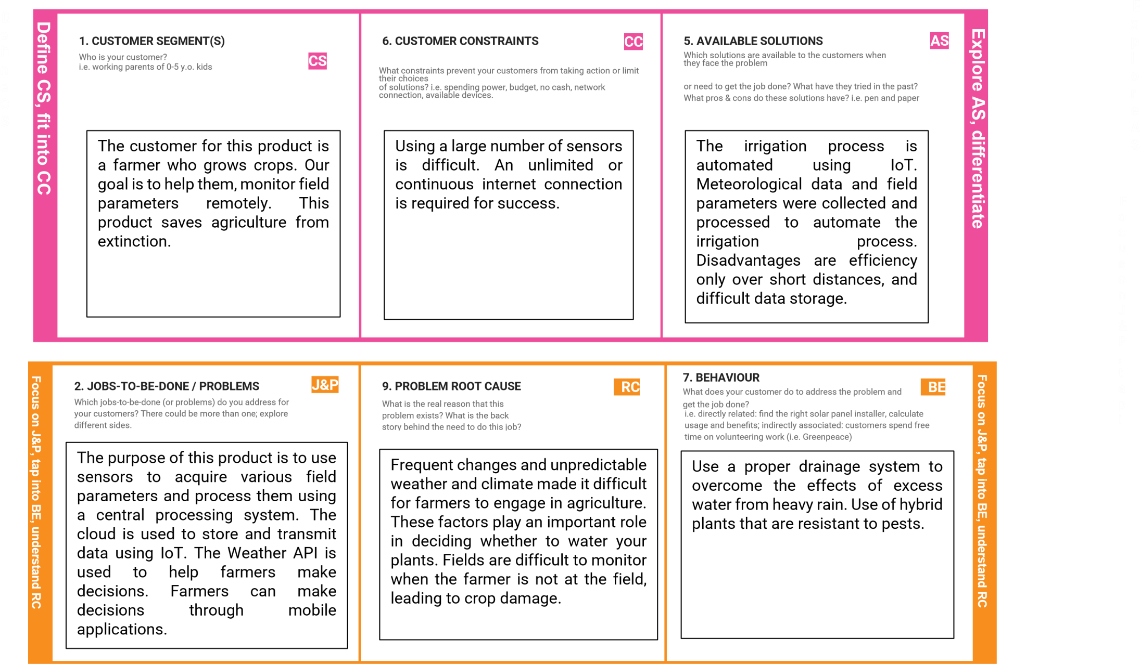

A farmer who raises crops is the target market for this product. Our intention is to assist them by remotely monitoring field conditions.

This product prevents the demise of agriculture.

Using numerous sensors is challenging. A number continued Internet connection is essential for success.

Weather data and fields collect parameters, processed to automate irrigation process.

Efficiency is a disadvantage only at close range Difficult data storage.

The purpose of this product is to employ sensors allowing acquisition of different fields settings and treat them with one centralized processing system. On

cloud-based usage.

Frequent changes and unpredictability made the task difficult due to weather and climate to get farmers in the business. These factors play an important role When deciding whether to water you plant. Difficult to monitor field when the farmer is not in the field, lead to crop damage.

To do this, use a suitable drainage system Overcome the Effects of Abundance water from heavy rain. Using hybrid A pest-resistant plant.

|  |  |  |  |  |  |  |
| --- | --- | --- | --- | --- | --- | --- |
|  | **3. TRIGGERS** | **TR** |  | **10. YOUR SOLUTION SL** | **8. CHANNELS of BEHAVIOUR CH** |  |
| What triggers customers to act? i.e., seeing their neighbor installing solar |  |  | If you are working on an existing business, write down your current | **8.1 ONLINE** |
| panels, reading about a more efficient solution in the news. |  |  | solution first, fill in the canvas, and check how much it fits reality. If you are working on a new business proposition, then keep it blank until you fill in the canvas and come up with a solution that fits within customer limitations, solves a problem and matches customer behaviour.  This product is data from Various types of sensors and sends main server value. Also gather weather data from Weather API. final decision Crops are irrigated by farmers in a mobile application. | What kind of actions do customers take online? Extract online channels from #7  **8.2 OFFLINE**  What kind of actions do customers take offline? Extract offline channels from #7 and use them for customer development.  ONLINE:provide online help for in providing knowledge about farmers,Soil pH and water content. Online User assistance  Product use.  OFFLINE:Become an awareness camp Organized to teach meaning, Benefits of Automation and IoT in agricultural development. |
| Farmers fight to offer Appropriate  Irrigation. Inadequate water supply will decrease Affects yields and farmer profit levels  Farmers are hard to predict weather. | |  |
| **4. EMOTIONS: BEFORE / AFTER EM**  How do customers feel when they face a problem or a job and afterwards?  i.e. lost, insecure > confident, in control - use it in your communication strategy & design. | | |
| BEFORE: Lack of knowledge in weather forecasting -›Random decisions -»low yield.  AFTER: Data from reliable source correct decision  ›high yield | | |  |  |

Farmers struggle to provide adequate irrigation.

Inadequate water supply reduces yields and affects farmers' profit levels. Farmers have a hard time predicting the weather.

Our product collects data from various

types of sensors and sends the values to our main server. It also collects weather data from the Weather API. The final decision to irrigate the crop is made by the farmer using a mobile application.

**Project Design Phase-I Solution Fit Template**

ONLINE: Providing online assistance to the

farmer, in providing knowledge regarding the pH and moisture level of the soil. Online assistance to be provided to the user in using the product

OFFLINE: Awareness camps to be organized to teach the importance and advantages of the automation and IoT in the development of agriculture.

BEFORE: Lack of knowledge in weather

forecasting →Random decisions →low yield.

AFTER: Data from reliable source → correct decision →high yield

# REQUIREMENT ANALYSIS

* 1. **Non-Functional Requirements:**

**Solution Requirements (Functional & Non-functional)**

|  |  |  |
| --- | --- | --- |
| **FR No.** | **Non-Functional Requirement** | **Description** |
| NFR-1 | **Usability** | It uses remote sensors,analytical tools,and the whole system is monitored and managed through websites. This makes them User friendly of the system and no use of this product.No prior knowledge required. |
| NFR-2 | **Security** | This system includes data masking, which is the process of removing all personally identifiable information from data, such as names, addresses, geographical identifiers, and access controls that help maintain privacy and security. |
| NFR-3 | **Reliability** | It is possible to endure extreme weather events and open space circumstances by using sensors, specialised software, and IOT platforms. The system can last a longer time and delivers reliable data measurement. |
| NFR-4 | **Performance** | Utilizing contemporary technical innovations aids in bridging the gap between production and yields in terms of both quantity and quality. Data Ingestion ensures quick action and less harm to the crops while boosting system performance by collecting and importing data from the many sensors for usage in real- time or database storage. |
| NFR-5 | **Availability** | By incorporating new components with superior characteristics, the current system can be made better. |

|  |  |  |
| --- | --- | --- |
|  |  | By connecting data about crops (or weather) and equipment to automatically modify temperature and humidity, farming equipment  can be adjusted automatically. |
| NFR-6 | **Scalability** | The cloud database deployment used by this system can be thought of as the medium in between the hardware system and the user's mobile app.  The proposed method is scalable thanks to increased productivity, decreased operating costs, and  precise farm and field evaluation. |

* 1. **Functional Requirement:**

Following are the functional requirements of the proposed solution.

|  |  |  |
| --- | --- | --- |
| **FR**  **No.** | **Functional Requirement (Epic)** | **Sub Requirement (Story / Sub-Task)** |
| FR- 1 | User Registration | Registration through Form Registration through Gmail |
| FR- 2 | User Confirmation | Confirmation via Email Confirmation via OTP |
| FR- 3 | Login | Check username and password Check access from another device |
| FR- 4 | Management of data | Managing data of crop conditions Managing data of weather conditions |
| FR- 5 | Management of Modules | Managing user  Managing admins Managing roles of access |
| FR- 6 | Logout | Exit |

# PROJECT DESIGN

## Data Flow Diagram :

**Data Flow Diagrams:**

A Data Flow Diagram (DFD) is a traditional visual representation of the information flows within a system. A neat and clear DFD can depict the right amount of the system requirement graphically. It shows how data enters and leaves the system, what changes the information, and where data is stored.

## Smart Farming Data Flow:

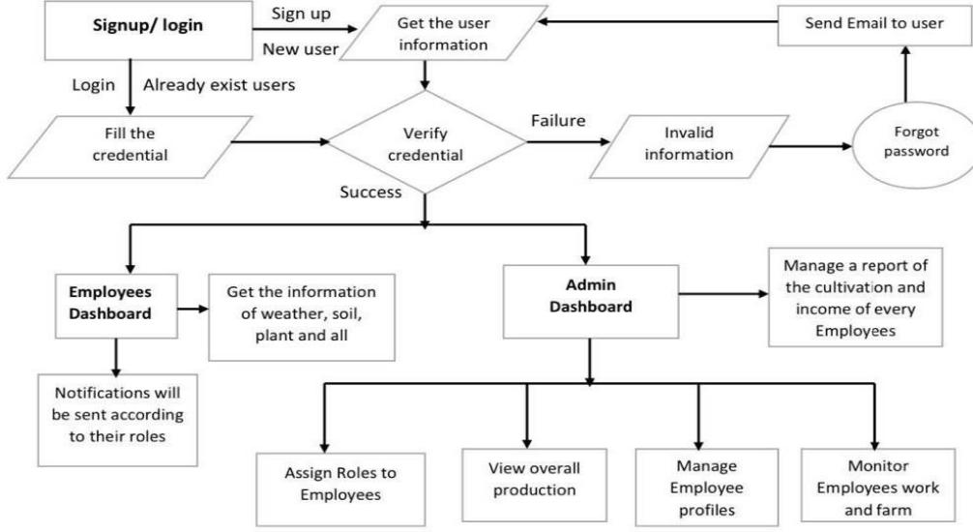

* 1. **User Stories**

Use the below template to list all the user stories for the product.

|  |  |  |  |  |  |  |
| --- | --- | --- | --- | --- | --- | --- |
| **User Type** | **Functional Requirement (Epic)** | **User Story Number** | **User Story / Task** | **Acceptance criteria** | **Priority** | **Release** |
| Customer (Mobile user) | Registration | USN-1 | As a Customer, I can register for the application  by entering my email, password, and confirming my password. | I can access my account / dashboard | High | Sprint-1 |
|  |  | USN-2 | As a user, I will receive confirmation email once I have registered for the application | I can receive confirmation email & click confirm | High | Sprint-1 |
|  |  | USN-3 | As a user, I can register for the application through Facebook | I can register & access the dashboard with Facebook  Login | Low | Sprint-2 |
|  |  | USN-4 | As a user, I can register for the application through Gmail |  | Medium | Sprint-1 |
|  | Login | USN-5 | As a user, I can log into the application by entering email & password |  | High | Sprint-1 |
|  | Dashboard | USN-6 | As a customer, I need to receive notification and details. | I get the details about what need to be done in different weather condition. | High | Sprint-1 |
| Customer (Web user) |  | USN-7 | As a user, I can reset my password if I forgot the old one. | I can use my account even if I forgot my password. | Medium | Sprint-2 |
| Customer Care Executive | Know more | USN-8 | As a user,I will be learn more about the work to be done. | Give more details from the data. | Medium | Sprint-3 |
| Administrator | Assignment of roles | USN-9 | As a admin, I will be able to assign role to the user. | I can assign role to the users. | High | Sprint-1 |
|  |  | USN-10 | As a admin,I can note done the progress of all the expense of the work done. | I can note down | Low | Sprint-3 |

## Solution & Technical Architecture:

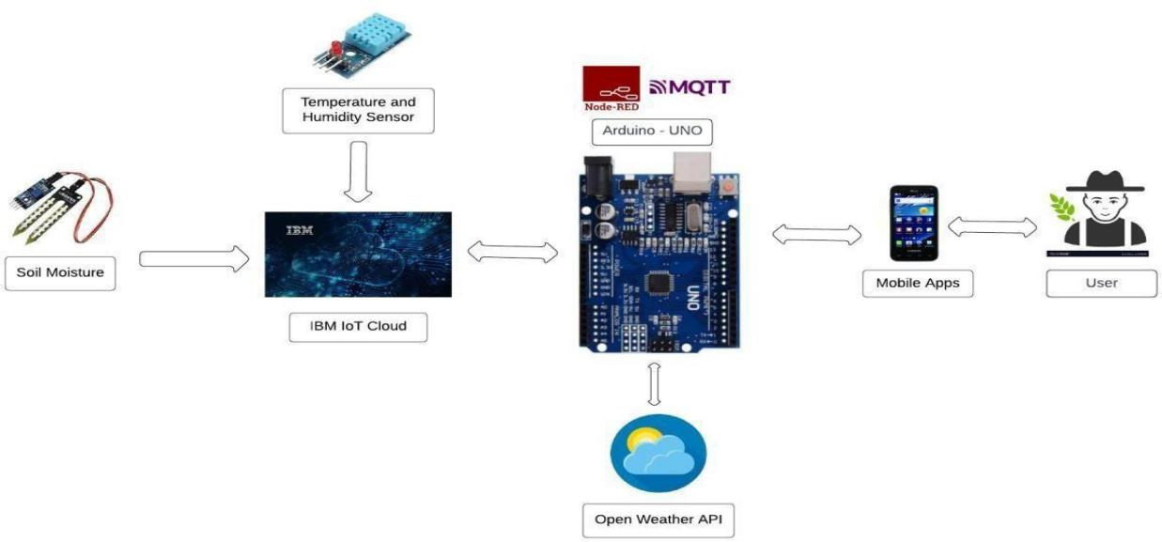

* Utilizing a variety of sensors, the various soil parameters (temperature, humidity, and soil moisture) are measured, and the results are saved in the IBM cloud.
* The processing unit used to process weather data from weather API and data from sensors is called Arduino UNO.
* The hardware, software, and APIs are wired using the programming tool Node- red.
* For communication, the MQTT protocol is used.
* Through a smartphone application created with the aid of MIT App Inventor, the user is given access to all the collected data. Depending on the sensor results, the user may decide whether to irrigate the crop or not using an app.

*They can control the motor switch from a distance using the app.

**Technical Architecture:**

The Deliverable shall include the architectural diagram as below and the information as per the table1 & table 2

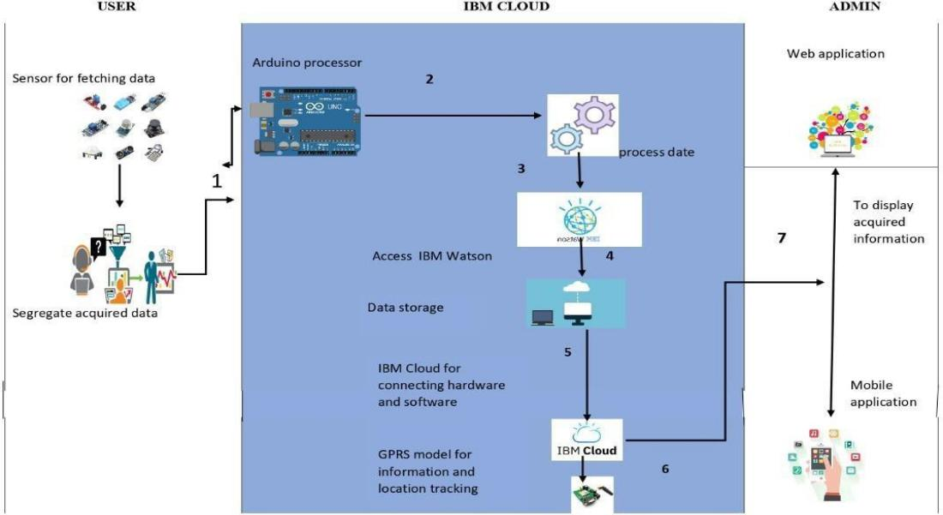

Guidelines:

. Include all the processes (As an application logic / Technology Block)

. Provide infrastructural demarcation (Local / Cloud)

. Indicate external interfaces (third party API’s etc.)

. Indicate Data Storage components / services

. Indicate interface to machine learning models (if applicable)

**Table-1 : Components & Technologies:**

|  |  |  |  |
| --- | --- | --- | --- |
| **S.No** | **Component** | **Description** | **Technology** |
| 1. | User Interface | The user will receive the processed information via  message or mail after using a mobile app or web application. | HTML, CSS, JavaScript / Angular Js / React Js etc. |
| 2. | Application Logic-1 | The code will incorporate a number of circumstances, such as controlling water flow based on moisture content and humidity levels, and notifying users through message and mail if temperatures rise above a  specific threshold. | Java / Python |
| 3. | Application Logic-2 | In this case, we can create a device and then design the software process by adding Node RED as an interface. | IBM Watson STT service |
| 4. | Application Logic-3 | Here, the conditions and sensed data can be compared to determine the ultimate outcome. | IBM Watson Assistant |
| 5. | Database | To allow users to obtain data whenever needed, we can store all the data in SQL or any other database. | MySQL, NoSQL, etc. |
| 6. | Cloud Database | We may combine the database we built with  predetermined data from external APIs, such as the weather, and store them securely for future use. | IBM DB2, IBM Cloudant etc. |
| 7. | File Storage | The fetched data can be stored in a file in IMB Block Storage or local filesystem for analysis | IBM Block Storage or Other Storage Service or Local Filesystem |
| 8. | External API-1 | Only with the aid of other APIs can we learn the current weather conditions and compare them to our sensed data. | IBM Weather API, etc. |
| 9. | External API-2 | It can be linked with Aadhar or integrated with some other applications with the help of API | Aadhar API, etc. |
| 10. | Machine Learning Model | Machine Learning algorithm can be used for Oblect Recognition, Prediction of weather Condition | Object Recognition Model, etc. |
| 11. | Infrastructure (Server / Cloud) | Application Deployment on Local System / Cloud Local Server Configuration:Own ideas  Cloud Server Configuration :IBM Cloud | Local, Cloud Foundry, Kubernetes, etc. |

**Table-2: Application Characteristics:**

|  |  |  |  |
| --- | --- | --- | --- |
| **S.No** | **Characteristics** | **Description** | **Technology** |
| 1. | Open-Source Frameworks | List the open-source frameworks used | Technology of Opensource framework |
| 2. | Security Implementations | Here, we are using the IBM Cloud, which is a very safe  location from where we can store data and access it as needed and encryption. | Encryption |
| 3. | Scalable Architecture | Cloud-based IoT is a solution that is growing more and more popular and desired. In this study, an architecture specifically developed for monitoring cattle using Internet of Things (IoT) devices and a wide range of cloud native applications is presented. IBM executed a stress test to demonstrate the viability of the designed architecture for data processing. | IBM Cloud |
| 4. | Availability | This application has a lot of important features available. Instead of wasting time by staying on the farm and monitoring the conditions, we have the moisture, humidity, and temperature which will denote the corresponding quantities. Additionally, we have both automatic and manual mode so once the certain conditions are met pump will be on/off and messages will be sent when needed so the farmer only needs to  check the message in their phone and can take decisions in accordance with | IBM Watson IoT, IBM Cloud, Weather API’S, Analytics, Sensor Networks |
| 5. | Performance | **Quality improvement:** Farmers may better comprehend the intricate relationships between environmental factors and crop quality using soil and crop sensors, aerial drone surveillance, and farm mapping. | IBM Watson IoT, Weather API’S, Analytics, Sensor Networks, IBM Cloud |

|  |  |  |  |
| --- | --- | --- | --- |
|  |  | **Increased efficiency:** Farmers must produce more despite failing soil, dwindling land availability, and growing weather variability. Farmers can monitor their product and environmental conditions in realtime thanks to IoT-enabled agriculture. They can quickly gain insights, anticipate problems before they arise, and decide how to prevent them using knowledge. IoT solutions for farming also include automation, such as demand-based irrigation, fertilisation, and robot harvesting.  **Increased Usage:** 70% of the population will reside in cities by the time there are 9 billion people on the earth. Short food supply chains are made possible by IoT- based greenhouses and hydroponic systems, which should be able to feed everyone. Smart closed-cycle agricultural systems make it possible to grow food virtually anywhere, even on the walls and rooftops of buildings, in shipping containers, and, of course, inside everyone's cosy homes.  **Reduced resources:** Agriculture in plenty IoT solutions are geared toward maximising the use of resources, including land, water, and energy. IoTbased precision farming depends on data gathered from various field sensors, which enables farmers to precisely allocate the right amount of resources to each plant.  **Agility:** One of the benefits of using IoT in agriculture is the increased agility of the processes. In the conditions of extreme weather changes, new capabilities help agriculture professionals save the crops. |  |

# PROJECT PLANNING & SCHEDULING

## Sprint Planning, Estimation & Schedule

|  |  |  |  |  |  |  |
| --- | --- | --- | --- | --- | --- | --- |
| **Sprint** | **Functional Requirement (Epic)** | **User Story Number** | **User Story / Task** | **Story Points** | **Priority** | **Team Members** |
| Sprint-1 | Simulation creation | USN-1 | python code | 2 | High | Jananee, Manish Sakkaravarty |
| Sprint-2 | Software | USN-2 | Creating device in the IBM Watson IoT  platform, workflow for IoT scenarios using Node- Red | 2 | High | Raghul,Dhivya |
| Sprint-3 | MIT App Inventor | USN-3 | Develop an application for the Smart farmer project using MIT App Inventor | 2 | High | Jananee,Raghul |
| Sprint-3 | Dashboard | USN-3 | Design the Modules and test the app | 2 | High | Jananee, Manish Sakkaravarty |
| Sprint-4 | Web UI | USN-4 | To make the user to interact with software. | 2 | High | Dhivya,Raghul |

**Project Tracker, Velocity & Burndown Chart: (4 Marks)**

|  |  |  |  |  |  |  |
| --- | --- | --- | --- | --- | --- | --- |
| **Sprint** | **Total Story Points** | **Duration** | **Sprint Start Date** | **Sprint End Date (Planned)** | **Story Points Completed (as on Planned End Date)** | **Sprint Release Date (Actual)** |
| Sprint-1 | 20 | 6 Days | 24 Oct 2022 | 29 Oct 2022 | 20 | 29 Oct 2022 |
| Sprint-2 | 20 | 6 Days | 31 Oct 2022 | 05 Nov 2022 |  | 05 Oct 2022 |
| Sprint-3 | 20 | 6 Days | 07 Nov 2022 | 12 Nov 2022 |  | 12 Oct 2022 |
| Sprint-4 | 20 | 6 Days | 14 Nov 2022 | 19 Nov 2022 |  | 15 Oct 2022 |

* 1. **Milestone and Activity List**

|  |  |  |
| --- | --- | --- |
| **Title** | **Description** | **Date** |
| Literature Survey & Information Gathering | Literature survey on the selected project & gathering information by referring the, technical papers, research publications etc. | 09 OCTOBER 2022 |
| Prepare Empathy Map | Prepare Empathy Map Canvas to capture the user Pains & Gains,  Prepare list of problem statements. | 09 SEPTEMBER  2022 |
| Brainstorming ideas | List the ideas by organizing the brainstorming session and prioritize the top 3 ideas based on the feasibility & importance. | 09 SEPTEMBER  2022 |
| Proposed Solution | Prepare the proposed solution document, which includes the novelty, feasibility of idea, business model, social impact, scalability of solution, etc. | 09 OCTOBER 2022 |
| Problem Solution Fit | Prepare problem - solution Fit document. | 09 0CTOBER 2022 |
| Solution Architecture | Prepare solution Architecture document. | 09 OCTOBER 2022 |
| Customer Journey | Prepare the customer journey maps to understand the user interactions & experiences with the application | 20 OCTOBER 2022 |
| Data Flow Diagrams | Draw the data flow Diagrams and submit for review. | 20 OCTOBER 2022 |
| Technology Architecture | Architecture diagram. | 20 OCTOBER 2022 |
| Sprint Delivery | Prepare the Sprint delivery on Number of Sprint planning meetings organized,  Minutes of meeting recorded. | 04 NOVEMBER  2022 |
| Milestone & Activity List | Prepare the milestones & Activity list of the project. | 04 NOVEMBER  2022 |
| Project Development Delivery of Sprints | Develop & submit the developed code by testing it. | 14 NOVEMBER  2022 |

# CODING & SOLUTIONING

## Feature 1:

Node-RED is a flow-based development tool for visual programming developed originally by IBM for wiring together hardware devices, APIs and online services as part of the Internet of Things. Node-RED provides a web browser-based flow editor, which can be used to create JavaScript functions.

Installation :

* + - First install npm/node.js
    - Open cmd prompt
    - Type => npm install node-red To run the application :
    - Open cmd prompt
    - Type=>node-red
    - Then open http://localhost:1880/ in browser

## IBM Watson IoT Platform:

A fully managed, cloud-hosted service with capabilities for device registration, connectivity, control, rapid visualization and data storage. IBM Watson IoT Platform is a managed, cloud-hosted service designed to make it simple to derive value from your IoT devices.

Steps to configure:

* + - Create an account in IBM cloud using your email ID
    - Create IBM Watson Platform in services in your IBM cloud account
    - Launch the IBM Watson IoT Platform
    - Create a new device
    - Give credentials like device type, device ID, Auth. Token
    - Create API key and store API key and token elsewhere.

## Python IDE:

Install Python3 compiler Install any python IDE to execute python scripts. The python code subscribed to IoT platform to form the connectivity layer with node -red commands.

## Connecting IoT Simulator to IBM Watson IoT Platform:

Give the credentials of your device in IBM Watson IoT Platform Click on connect My credentials given to simulator are:

organization = "ie8mpi" deviceType = "IoT_device" deviceId = "IoT_device_1" authMethod = "token" authToken = "12345678”

You can see the received data in graphs by creating cards in Boards tab

* You will receive the simulator data in cloud
* You can see the received data in Recent Events under your device
* Data received in this format(json) You can see the received data in graphs by creating cards in Boards tab
* You will receive the simulator data in cloud
* You can see the received data in Recent Events under your device
* Data received in this format(json)

{

"d": {

* "name": "abcd",
* "temperature": 17,
* "humidity": 76,
* "Moisture ": 25

}

}

## Configuration of Node-Red to collect IBM cloud data:

The node IBM IoT App In is added to Node-Red workflow. Then the appropriate device credentials obtained earlier are entered into the node to connect and fetch device telemetry to Node-Red.Once it is connected Node-Red receives data from the device Display the data using debug node for verification Connect function node and write the Java script code to get each reading separately. The Java script code for the function node is: msg.payload=msg.payload.d.temperature return msg; Finally connect Gauge nodes from dashboard to see the data in UI

# FEATURE 2:

## Configuration of Node-Red to collect data from OpenWeather

The Node-Red also receive data from the OpenWeather API by HTTP GET request. An inject trigger is added to perform HTTP request for every certain interval. HTTP request node is configured with URL we saved before in section The data we receive from OpenWeather after request is in below JSON

[https://api.openweathermap.org/data/2.5/weather?q=tiruvannamalai&appid=c5ac3c548](https://api.openweathermap.org/data/2.5/weather?q=tiruvannamalai&appid=c5ac3c5487ad57ad7d180da88716ea93) [7ad57ad7d180da88716ea93](https://api.openweathermap.org/data/2.5/weather?q=tiruvannamalai&appid=c5ac3c5487ad57ad7d180da88716ea93)

{"coord":{"lon":79.0667,"lat":12.2167},"weather":[{"id":804,"main":"Clouds","descrip tion":"overcast clouds","icon":"04n"}],"base":"stations","main":{"temp":295.77,"feels_like":296.54,"te mp_min":295.77,"temp_max":295.77,"pressure":1015,"humidity":94,"sea_level":1015," grnd_level":995},"visibility":10000,"wind":{"speed":2.05,"deg":29,"gust":4.22},"cloud

s":{"all":96},"dt":1668440978,"sys":{"country":"IN","sunrise":1668386454,"sunset":16 68428130},"timezone":19800,"id":1254327,"name":"salem","cod":200}

In order to parse the JSON string we use Java script functions and get each parameters In order to parse the JSON string we use Java script functions and get each parameters

var temperature = msg.payload.main.temp; temperature = temperature-273.15;

return {payload : temperature.toFixed(2)};

In the above Java script code we take temperature parameter into a new variable and convert it from kelvin to Celsius Then we add Gauge and text nodes to represent data visually in UI.In the above Java script code we take temperature parameter into a new variable and convert it from kelvin to Celsius Then we add Gauge and text nodes to represent data visually in UI.

## Configuration of Node-Red to send commands to IBM cloud ibmiot out node:

I used to send data from Node-Red to IBM Watson device. So, after adding it to the flow we need to configure it with credentials of our Watson device.

Here we add two buttons in UI

1. -> for motor on
2. -> for motor off

We used a function node to analyses the data received and assign command to each number.

The Java script code for the analyses is:

if(msg.payload===1) msg.payload={"command”: “ON"}; else if(msg.payload===0) msg.payload={"command”: “OFF"}

## Adjusting User Interface:

To display the parsed JSON data a Node-Red dashboard is created Here we are using Gauges, text and button nodes to display in the UI and helps to monitor the parameters and control the farm equipment. Below images are the Gauge, text and button node configurations.

## Using MIT APP Inventor:

It facilitate farmer to know the current parameters of their land through mobile app which already connected with web UI.Farmer can turn on or off the motor according to the condition of the field

**FEATURE 1**

PYTHON CODE:

import time import sys

import ibmiotf.application import ibmiotf.device

#Provide your IBM Watson Device Credentials organization = "ie8mpi"

deviceType = "IoT_device" deviceId = "IoT_device_1" authMethod = "token" authToken = "12345678”

def myCommandCallback(cmd): print("Command received: %s" %cmd.data)

if cmd.data['command']=='motoron': print("MOTOR ON IS RECEIVED")

elif cmd.data['command']=='motoroff': print("MOTOR OFF IS RECEIVED")

if cmd.command == "setInterval":

if 'interval' not in cmd.data:

print("Error - command is missing required information: 'interval'")

else:

interval = cmd.data['interval']

elif cmd.command == "print": if 'message' not in cmd.data:

try:

else:

print("Error - command is missing required information: 'message'")

output=cmd.data['message'] print(output)

deviceOptions = {"org": organization, "type": deviceType, "id": deviceId, "auth- method": authMethod, "auth-token": authToken} deviceCli = ibmiotf.device.Client(deviceOptions)

#..............................................

except Exception as e:

print("Caught exception connecting device: %s" % str(e)) sys.exit()

# Connect and send a datapoint "hello" with value "world" into the cloud as an event of type

"greeting" 10 times deviceCli.connect()

while True:

deviceCli.commandCallback = myCommandCallback

# Disconnect the device and application from the cloud deviceCli.disconnect()

- t *X* l' , - - - *X* [;jl : _ Jl _ , X +

StuderitDHhboard X

**::!:111\llJ@ !'illl**

Python 3.15.2 (v3.6.2;5:fd33b5, Jul 8 2017, 04:14:34) [MSC v.1'900 32 bit (InteJ.)J

Typl"' "copyri1,ht", "crl"'dit'"''" or '"licl"'n;"'ll"'()" :for marl"' in:formation.

>» I

X

□

t_.aPython3.6.2Shell

File Edit Shell Debug Option Window Help

I

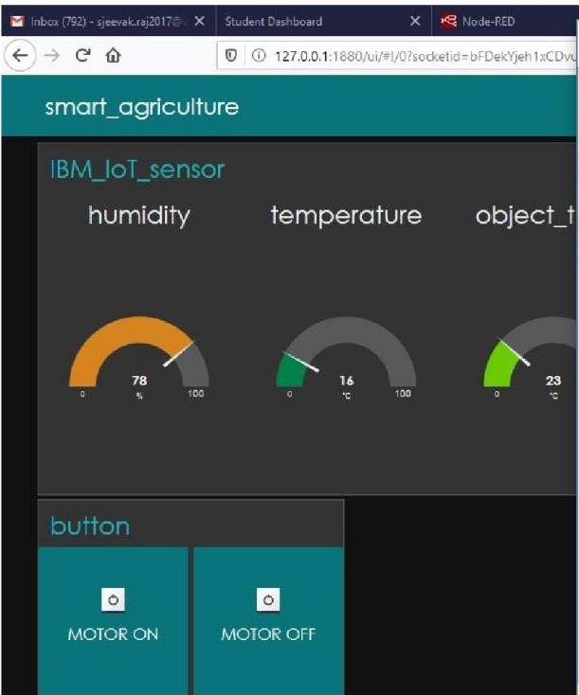

L4 'Python3.8.3Shell'

File Edrt: Shell Debug Options Window Help

□

X

Python 3.8.3 (ta0'.!!!/V3.8.3;6:l:8c832, May 13 2020, 22:37:02) (MSC v.1924 64 bit (AM

D6-5) I on win32

Iype **"he:J.p",** "copyriO"ht", "credit.!!" or "licen.!!e ()" :tor rr,ore .in:l:0D11ation .

.. RESIARI; C;/U.!!er.!!!/Admin/AppData/Local/Proqram.!!!/Python/Python38/.!!!IID.!!cribeibm.py 2020-05-30 16; 5-i; 37, 373 il:;m:i.otf. dl"'V:l.CI"' .Cl:i.ent

lly; d;ieer,.pi.;IoT_dl"'vicl"'; IoT_dl"'vicl"'_l CoICII'4nd received; {'corora.and'; 'motoron')

CoICII'.and :r:l"'cl"'ivl"'d; { 'co:mm.and'; 'm.otoroff')

CoICII'.and :r:l"'cl"'ivl"'d; { 'co:mm.and'; 'm.otoron')

{9 Whale.App X • (no subJt X 0 IBM X IBM EPB X ■Google K X Smart A( X IBM Pm1 X ' IBM aoud X (" IBM Wat X + *v* - '"jJ X

X ■ cloud1bmcom 2 * **1lt** □ J ;

C ,ital,w

§ IBM Cloud Q

ir1 ii'» hn<H'IPP r Ar,..,.., int *(?j* = V Q

ffil Untitled V

§ For you

<ili

t:dit dashboard £.

Upgrade account **iiiiifiHIFM**

quickStart.optionSelect v

=1.□

*'1}J*

|  |  |  |  |  |  |  |
| --- | --- | --- | --- | --- | --- | --- |
| @ | tutorials andservices. | Browse our starter kits, and  then select one to jump | Deploy a conversational interface com patibl-=with | Get started with using AI  and Cloud Object Storage in | developer tools, which  include the latest IBM Cloud | Upgrad  tocrea |
| 0  e, |  | start the process to create  and deploy your app. | any application, device, or  channel. | 15 minutes. | CLI, verify the installation,  and configure the environment. | ;ict  > 6. |
| C'o |  |  |  |  |  |  |

**Build**

E:xplore IBM Cloud with this selection of ea5Y starter

Create and deploy an application

Build a web app with Watson Speech lo Text

Get Started with Walson Studio

Get Started with the CLI Install the IBM Cloud"'

Build a

Cloud (

Getnngstaned 5min

**N**

+

News

Geltrngsianed

Popular

View all

Rei:ommended

10min

■

; Project & Spnnt Pl pdf .,,.., **Cl** app layout scree Jpeg .,,.., **Cl** http reques.t png .,,.., **Cl** Watson lol_platfo png .,,.., **Cl** mrt app mventor png .,,.., I Show all I X

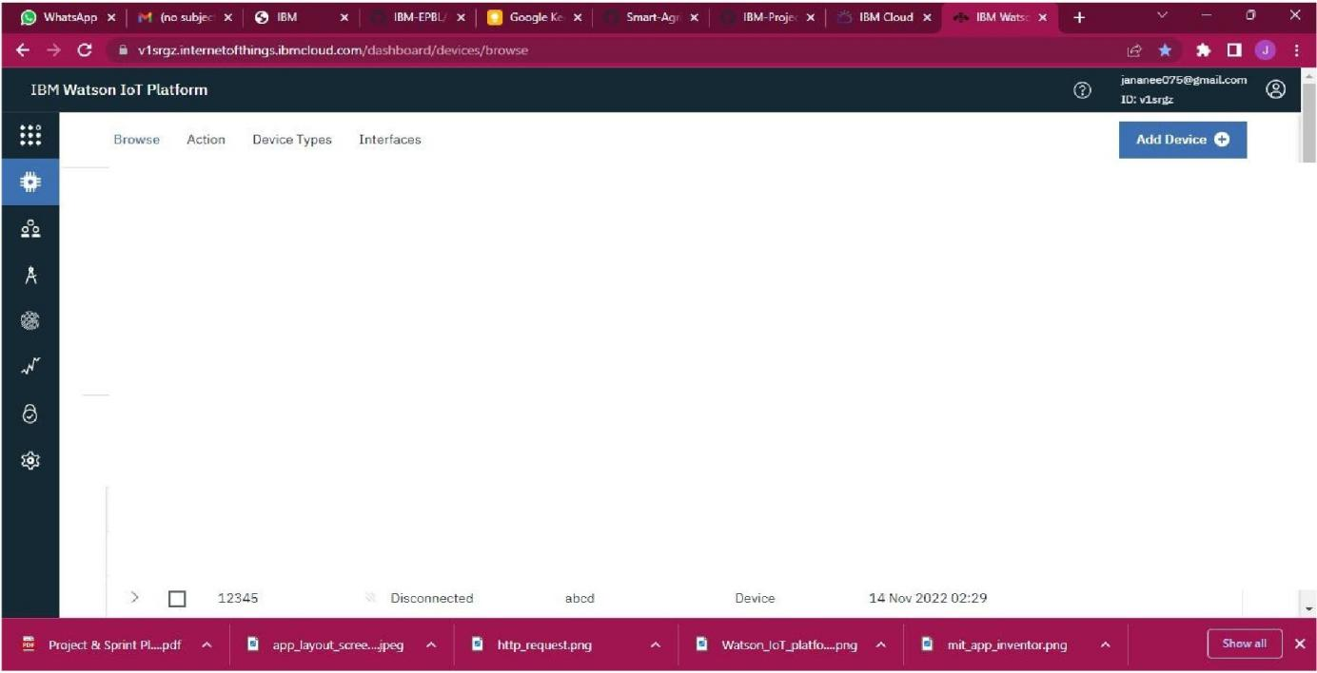

**EH+++** magnose

Browse Devices

This table shows a summary of all devices that have been added. It can be filtered, organized, and searched on using different

criteria. To get started, you can add devices by using the Add Device button, or by uslngAPI.

Q Search by Device ID

Device Simulator 0

**IOI**

|  |  |  |  |  |  |
| --- | --- | --- | --- | --- | --- |
| D | Device IO | Status | Device Type | Class ID | Date Added |
| **0** | 123 | Disconnected | openAPI | 0evicE- | 13 Nov 2022 23:01 |

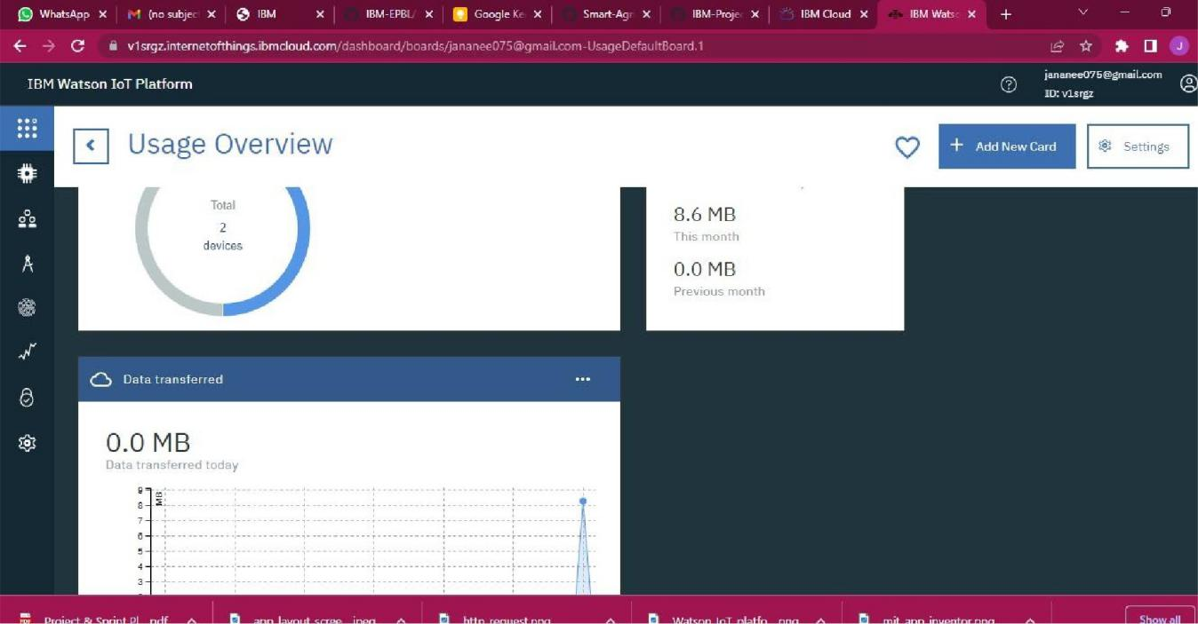C <D 1270.D11S80'"flo,•1/a4a15e6d:-b:-J6e :2' * * □ J :

-------7 --------------------< - Deploy - =.

-:

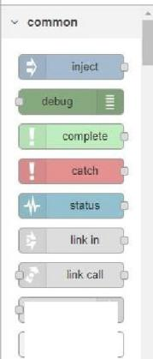

No(lH fH I)

linlcoul

comment

Tallnodes • 9a11 •

msg payload I

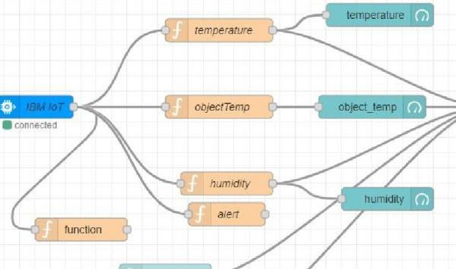

..., **function**

**"-1**- **0** ·+**·j**f ,,

; ProJect&SpnnlPI pdf A **C** applayoutscree Jpeg A **Cl** httprequeo;.lpng A **C** WatsonloT_platfo png A **Cl** mdappm,1entorpng A

**QFEIM@E** Appl1cat1, ><e: Node RE Student Da5fc i:3 MIT App loT 5ermir node red h5 node red h5, Node-P **X hi&IM:H**

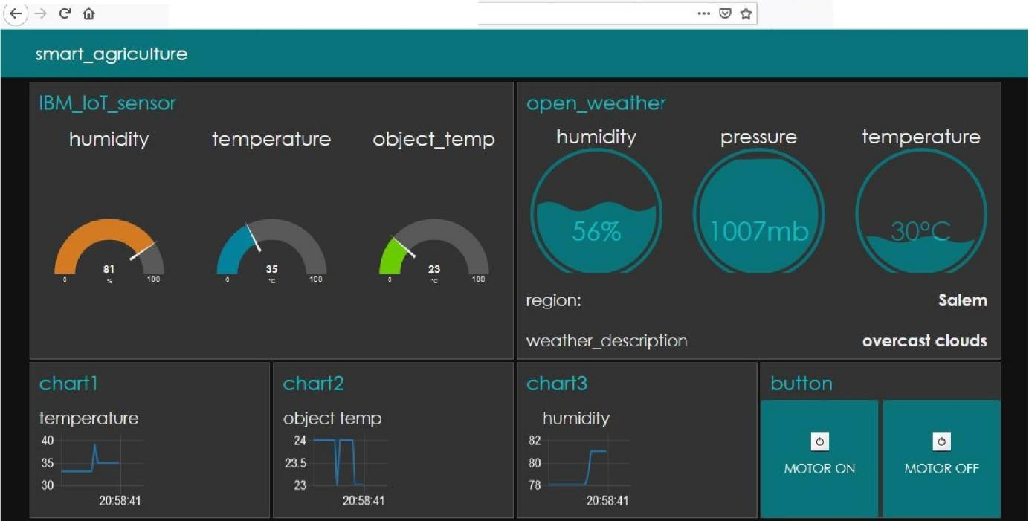

[_ © (D 127.0.0.1:1880/Lii/"'°!/O?socketid=SeoiBLBfRS6JIUSbfi.AAA ::!:: Ill\ ID @ t!J **!'ii 1!11**

(9

,E,-

WhatSJ. )( • (nowt- )( 0 IBM )( IBM E> )( Iii Googlr X Smart X IBM Pr X IBM O X IBM W X

C (D 127 O.D 1 1B80/""'flo,v19a€'c2cc lO'ec

Node )( + v - 0 X

12 * **,t** □ J ;

Nodo RLLJ -': Deploy • :

a filter nodes =FJow2 +



fl debug

Tall nodes - aall •

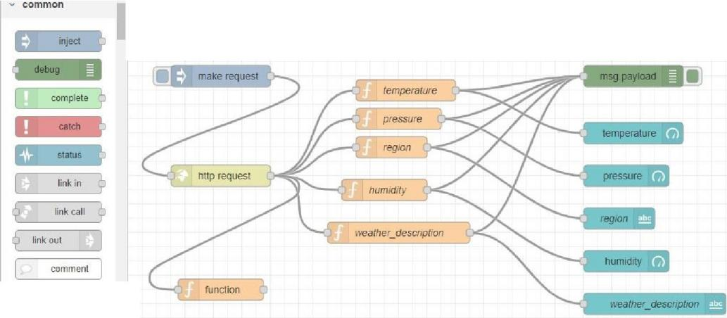

..., function

1270.0 l 1880/#9a8h2c<307ec

ProJect & Spnnl Pl pdf " ti app layout scree Jpeg " Cl http request prg " Cl Watson loT_platfo png " Cl mil app inventor png " X

;

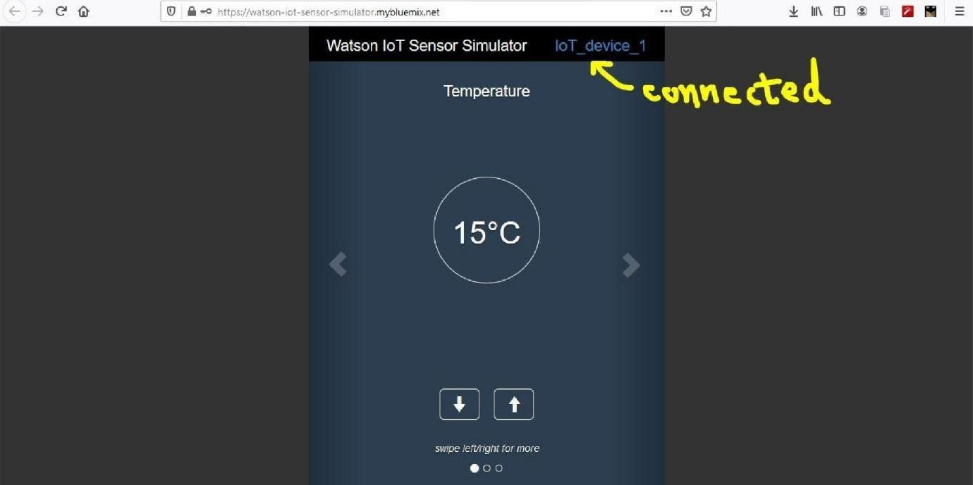

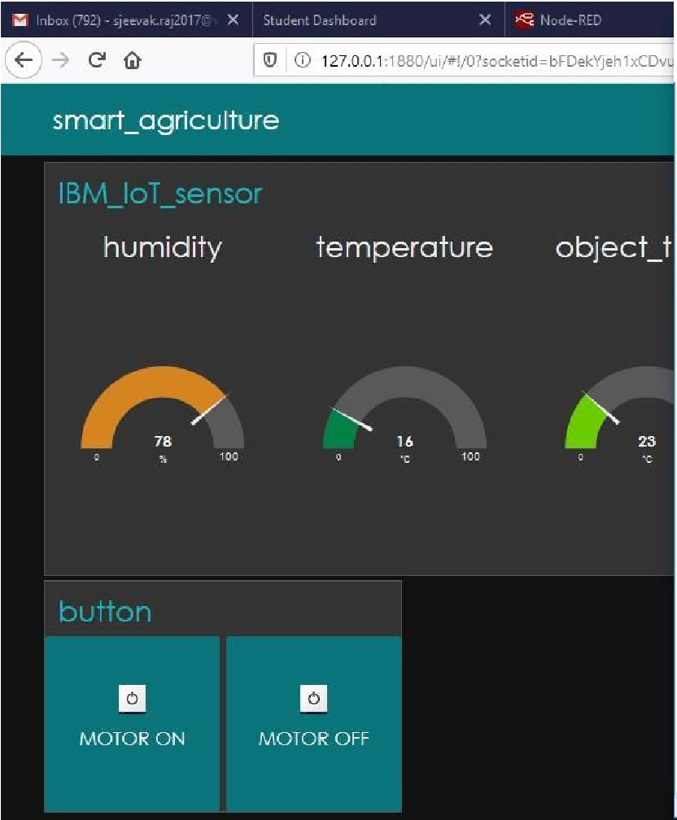

lo "Python3.S.3S.hell"

□

**X**

(D 127.0.0.1:1880/Lii/"'°!/O?socketid=bFDekYjeh1xCDv l--F_ile_E_dit_S_h,_II **_D_e_b, g_Op b_,,_s_W_i_,d_,w_H_e lp**

Python 3.8.3 (tat;1.5/v3.8.3;6f8c832, May 13 2020, 22;37;02) [MSC v.19:.!4 154 bit (A."'I:

D154)] on win32

Typl"' "hl"'lp", "copyrioht", "crl"'dit.5" o:r: "licl"'n.51"'()" for marl"' info=tion.

= RESTART: C: /Users/Admin/AppData/Local/Proor=/Python/Pyttmn38/slIDscribeibm. py 2020-05-30 16: 54: 37,373 ibmiotf. device. Cl.ient INFO Connected .5cccessfu lly: d: ie!!rr.pi: IoT_device; *Ioi* _device_ 1

Command received: {'con::mand'; 1ILOtoron')

Command received: {'cmr:rr.and'; 1ILOtoro.l".l"')

Co=.and rl"'cl"'iVl"'d: { 'co=nd'; 'ILOtoron') MOTOR ON IS Rl:C'EIVfD

W Seilrchre,ults, *X*  rv1ceDl"'tails II X

IBMWatsonloT• X S.tudentDashboard *X* <♦ loT'iensor

X

Ln:5 Col:O

G1tHub- 'imartP X @ 5.0 I moisture unit X + - ol X



lo "Python3.S.3S.hell"

□

**X**

(D 127.0.0.1:1 880/Lii/"'°!/O?socketid=bFDekYjeh1xCDv l--F_ile_E_dit_S_h,_II **_D_e_b, g_Op b_,,_s_W_i_,d_,w_H_e lp**

Python 3.8.3 (tat;1.5/v3.8.3;6f8c832, May 13 2020, 22;37;02) [MSC v.19:.!4 154 bit (A."'I:

D154)] on win32

Typl"' "hl"'lp", "copyrioht", "crl"'dit.5" o:r: "licl"'n.51"'()" for marl"' info=tion.

= RESTART: C: /Users/Admin/AppData/Local/Proor=/Python/Pyttmn38/slIDscribeibm. py 2020-05-30 16: 54: 37,373 ibmiotf. device. Cl.ient INFO Connected .5cccessfu lly: d: ie!!rr.pi: IoT_device; *Ioi* _device_ 1

Command received: {'con::mand'; 1ILOtoron')

Command received: {'cmr:rr.and'; 1ILOtoro.l".l"')

Co=.and rl"'cl"'iVl"'d: { 'co=nd'; 'ILOtoron') MOTOR ON IS Rl:C'EIVfD

Ln:5 Col:O

C ■ ap1openweathermap.org/d.ata,2 5/½t:atherJq-t1ru,1annamal.a1&app1d-c5ac3c5487.ad57ad7d180da88716e.a93 *

•

□ J ;



**FEATURE 2**

Develop an application for the Smart farmer project using MIT App Inventor and Design the Modules and test the app

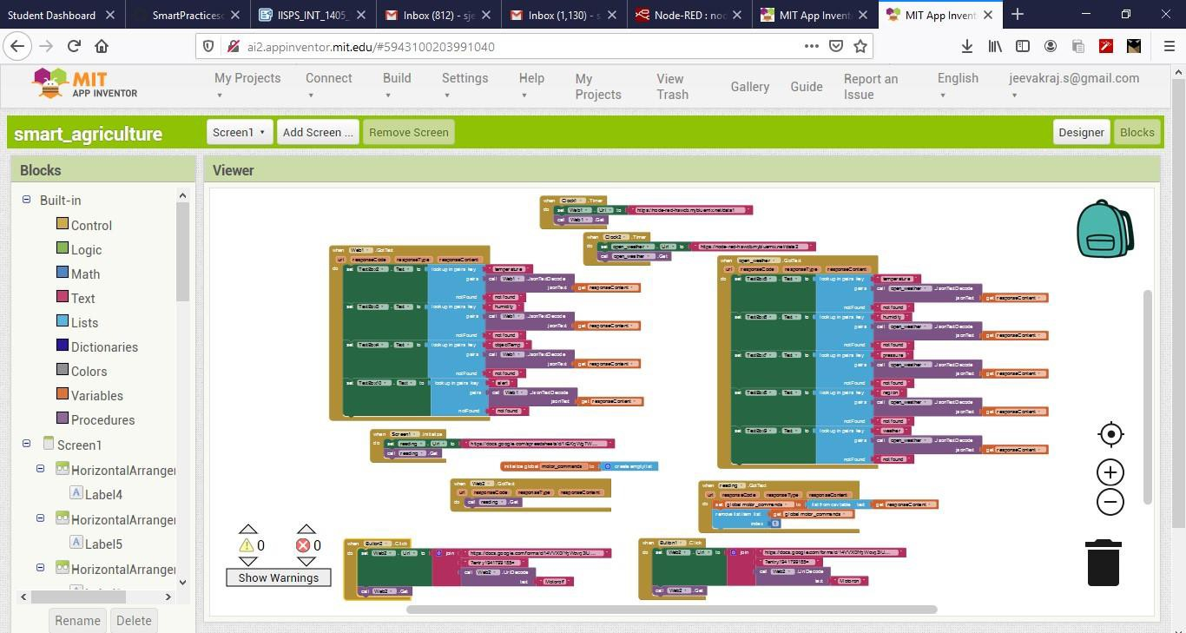

**MOBILE INTERFACE**

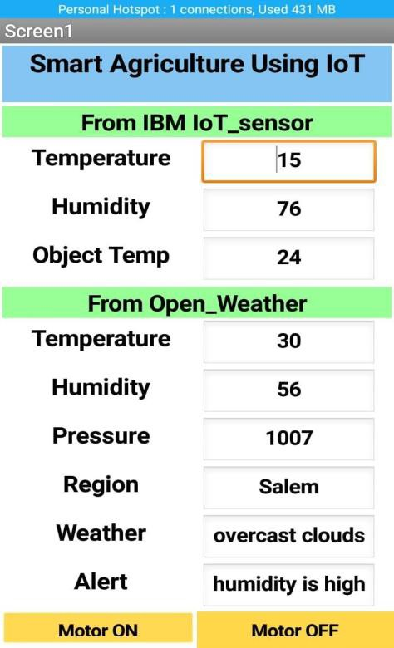

TEST THE UI INTERFACE :

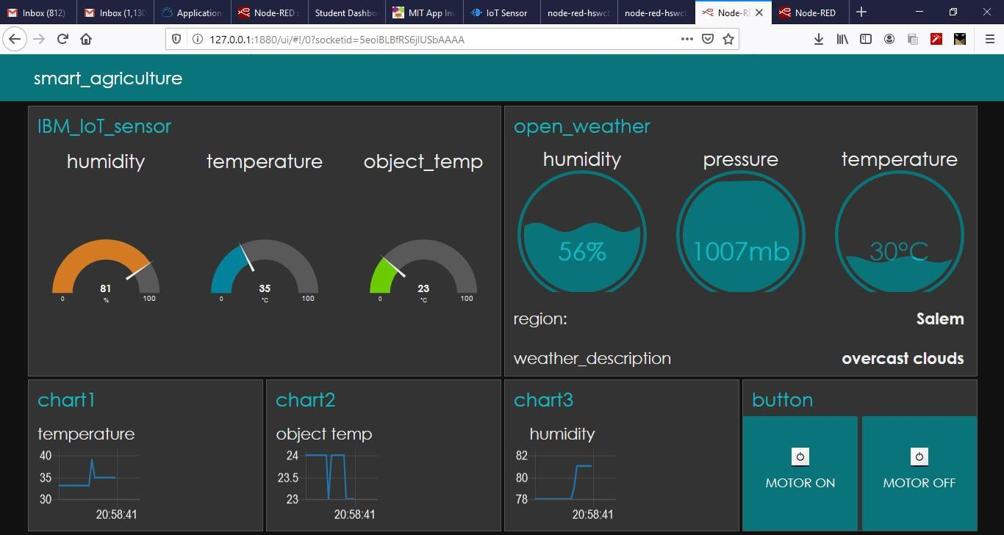

SUCCESSFULLY DEPLOYED:

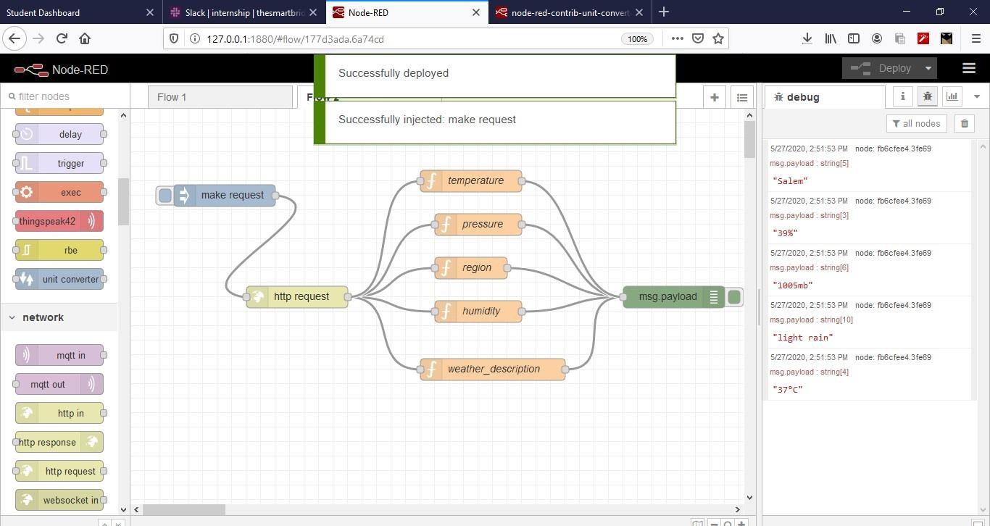

**MMI** , X S.erv1ceDehd -I X IBMW honloTe X **<t-** loTSemcn **xfiiiFIWII "EMF** X + - i:ll X

''''''*

lI.D **1111 ..o** https://watson-iot-sensor-simulator.mybluemix.nel ... *I ::!: 1111 llJ ® **El ti**

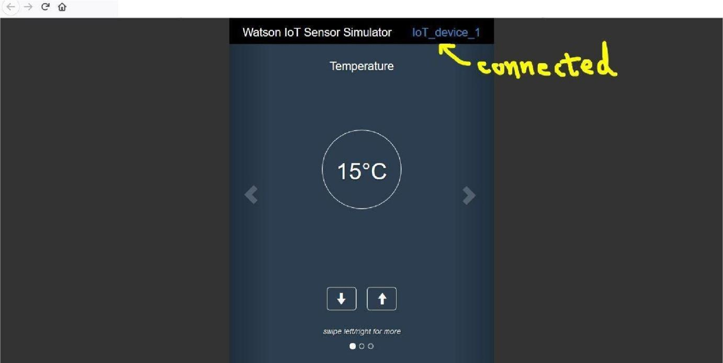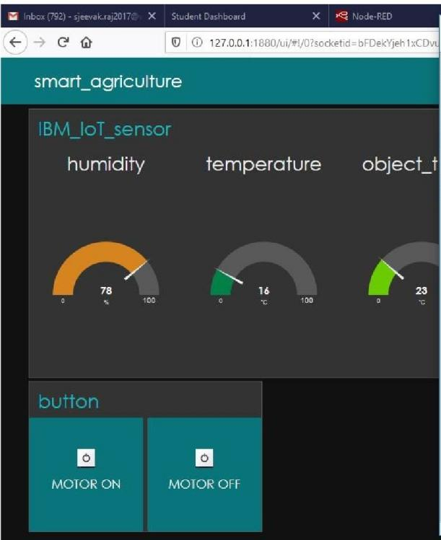

LO'Python3.8.3Shell'

File E.dit Shell Debug Option Window Help

Python 3.8.3 {ta1111/v3.8.3:6f8c832, May13 2020, 22:37:02) (MSC v.1924 64 bit (AM

D64) I on win32

Typl"' "h1"'1-p'", '"copyri11ht'", "crl"'dit11" or "licl"'n1'1"'()" fo:r: marl"' infoITllllltion.

□

X

= RESTART: C: /Users/Admin/ AppData/ Local/Programs/Python/Python33/ slIDscr ibeibm.py 2020-05-30 .l6: 54: 37,373 ibmiot:!'. device .Client INFO Connected successfu lly: d::te npi:IoT_device: IoT_device_l

Con.mand received: {'command': 'motoron'}

Corar ndreceived: {'core.rt.and': 'moto:::off'} Corar:and received: {'core.re.and': 'moto:::on')

Ln: '> Col:O

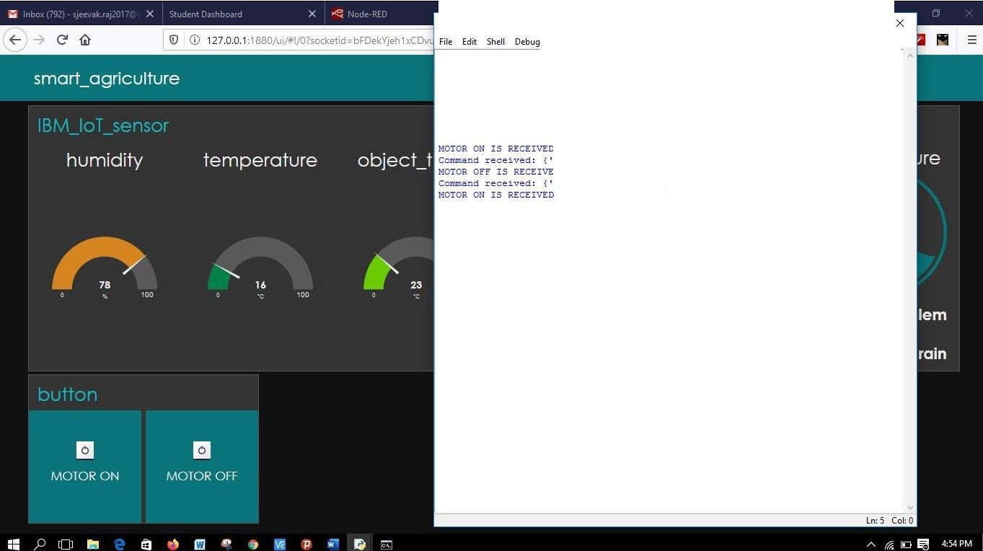

lo "Python 3.8.3 Shell'

□

Options Window Help

Python 3.8.3 (t1119s/v3.8.3:6t8c832, May 13 2020, 22:37:02) {MSC v.1921 61 bit (AM

064)) on win32

Type "help", "copyri9ht", "CI"edits" or "license()" tor Ir;Ore intormation.

>»

* RE.START: C: /UseI"s/Admin/AppD111t111/Loc111l/Pro9ra=/Python/Python38/ subscI"ibeibm. PY 2020-05-30 16: 51: 37,373 ibriu.ott .device.Client INFO Connecte::1 success*tu* lly: d: l.e8Itp1: IoT_device: IoT_device_l

Comna.ndreceived: {'con::mand' : 'motoron' )

Corm'.and received: {'corr.rnand' : 'rr.otorott'} MOTOR Of"f" IS RECEIVED

Co:rur.and received: {'corr:reand' : 'motoron' )

# TESTING

## Test Cases

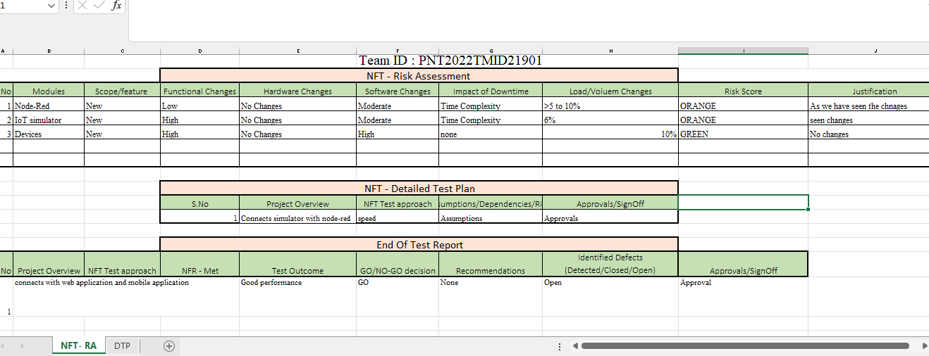

* 1. **User Acceptance Testing**

The purpose of this document is to briefly explain the test coverage and open issues of the “SmartFarmer - IoT Enabled Smart Farming Application” project at the time of the release to User Acceptance Testing (UAT). Increasing control over production leads to better cost management and waste reduction. The ability to trace anomalies in crop growth or livestock health, for instance, helps eliminate the risk of losing yields. Additionally, automation boosts efficiency. Smart farming reduces the ecological footprint of farming. Minimized or site-specific application of inputs, such as fertilizers and pesticides, in precision agriculture systems will mitigate leaching problems as well as the emission of greenhouse. This report shows the number of resolved or closed bugs at each severity level, and how they were resolved. This report shows the number of test cases that have passed, failed, and untested.

1. **DEFECT ANALYSIS**

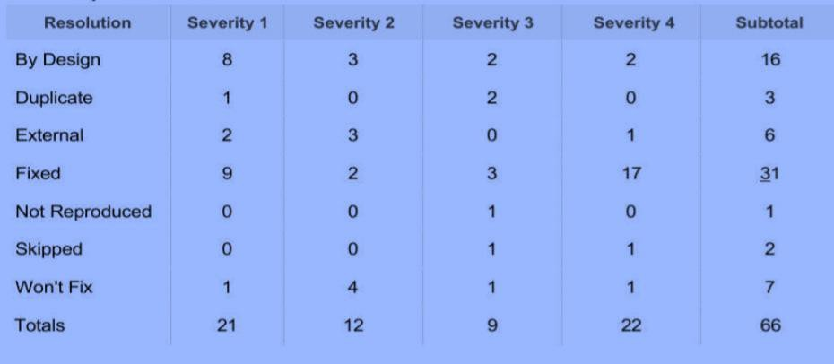

1. **TEST ANALYSIS**

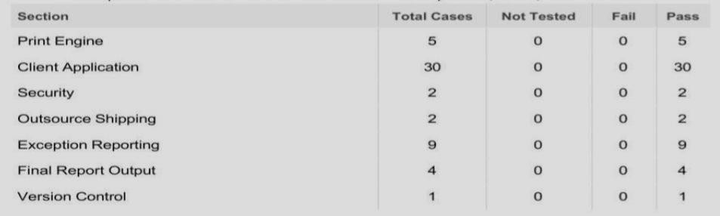

1. **RESULT:**
   1. **PERFORMANCE METRICS**

Hence a helpful and useful system is built for farmers to assist them in farming and also prevent them from natural calamities. It also saves farmers time to maintain all these things as this is working on cloud he can turn on/off motor from anywhere so basically it helps farmers and make them relived thus helping our economy to grow.

# ADVANTAGES & DISADVANTAGES:

## Advantage:

* monitoring weather parameters such as temperature, pressure, humidity, soil moisture remotely controlling motors easily through buttons
* alert farmers in case of any calamities
* threshold values are set any anomalies will be reported to the farmer
* user friendly and efficient
* low cost

## Disadvantage:

* sensors may sometime malfunction
* maybe inaccurate sometimes
* farmer needs internet connectivity
* farmer must have a phone and have basic knowledge to operate it

## Applications:

* Monitoring of Climate Conditions -Probably the most popular smart agriculture gadgets are weather stations, combining various smart farming sensors. Located across the field, they collect various data from the environment and send it to the cloud. The provided measurements can be used to map the climate conditions, choose the appropriate crops, and take the required measures to improve their capacity (i.e. precision farming).
* Greenhouse Automation-In addition to sourcing environmental data, weather stations can automatically adjust the conditions to match the given parameters. Specifically, greenhouse automation systems use a similar principle.
* Crop Management - One more type of IoT product in agriculture and another element of precision farming is crop management devices. Just like weather stations, they should be placed in the field to collect data specific to crop farming; from temperature and precipitation to leaf water potential and overall crop health, these can all be used to readily collect data and information for improved farming practices.
* Cattle Monitoring and Management-Just like crop monitoring, there are IoT agriculture sensors that can be attached to the animals on a farm to monitor their health and log performance. This works similarly to IoT devices for pet care.
* End-to-End Farm Management Systems-A more complex approach to IoT products in agriculture can be represented by the so-called farm productivity management systems. They usually include a number of agriculture IoT devices and sensors, installed on the premises as well as a powerful dashboard with analytical capabilities and in-built accounting/reporting features.

# CONCLUSION:

Smart Farming and IoT-driven agriculture are paving the way for what can be called a Third Green Revolution.The Third Green Revolution is taking over agriculture. That revolution draws upon the combined application of data-driven analytics technologies, such as precision farming equipment, IoT, “big data” analytics, Unmanned Aerial Vehicles (UAVs or drones), robotics, etc.

In the future this smart farming revolution depicts, pesticide and fertilizer use will drop while overall efficiency will rise. IoT technologies will enable better food traceability, which in turn will lead to increased food safety. It will also be beneficial for the environment, for example, more efficient use of water, or optimization of treatments and inputs.Therefore, smart farming has a real potential to deliver a more productive and sustainable form of agricultural production, based on a more precise and resource-efficient approach. New farms will finally realize the eternal dream of mankind.

# FUTURE SCOPE:

With the exponential growth of world population, according to the UN Food and Agriculture Organization, the world will need to produce 70% more food in 2050, shrinking agricultural lands, and depletion of finite natural resources, the need to enhance farm yield has become critical. Limited availability of natural resources such as fresh water and arable land along with slowing yield trends in several staple crops, have further aggravated the problem. Another impeding concern over the farming industry is the shifting structure of agricultural workforce. Moreover, agricultural labor in most of the countries has declined. As a result of the declining agricultural workforce, adoption of internet connectivity solutions in farming practices has been triggered, to reduce the need for manual labor.IoT solutions are focused on helping farmers close the supply demand gap, by ensuring high yields, profitability, and protection of the environment. The approach of using IoT technology to ensure optimum application of resources to achieve high crop yields and reduce operational costs is called precision agriculture. IoT in agriculture technologies comprise specialized equipment, wireless connectivity, software and IT services.